# Evading air-to-air missile

* Missile cannot turn tighter than the aircraft.
* In order to pull as tight turn as a fighter aircraft, missile has to pull amount of g that is amount of g’s aircraft can pull multiplied by difference in speed squared.
* Missile always attempts to lead the target. Thus if target changes heading, it will be hard pressed to correct.

|  |
| --- |
| Case with BVR missiles, where target fighter aircraft can turn so that missile faces its side and only enter a turn once missile is close.   * Beyond-visual-range [missile](http://en.wikipedia.org/wiki/Missile) (BVR): refers to an [air-to-air missile](http://en.wikipedia.org/wiki/Air-to-air_missile) (BVRAAM) that is capable of engaging at ranges of 20 nmi (37 km) or beyond. This range has been achieved using dual pulse [rocket motors](http://en.wikipedia.org/wiki/Rocket_motor) or booster rocket motor and [ramjet](http://en.wikipedia.org/wiki/Ramjet) sustainer motor. |
| http://defenseissues.files.wordpress.com/2013/08/evasion-g.jpg |

* Main problem with evading missiles is their speed, which makes timing somewhat difficult.

**Basic tactics to evade the missile:**

* First is a **barrel roll**. As missile is unable to track it, it will fly past and loose a lock in the process.

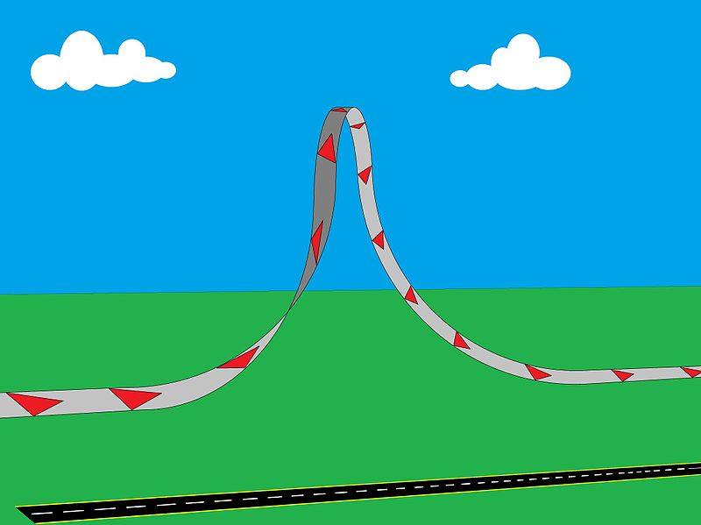

* Second is a **simple turn**, where pilot forces missile to follow it through a turn – this turn however must be well timed, and is very useful as an end move in more complex maneuvers designed to bleed off missile’s energy.
  + Very useful in a dogfight (aerial battle between [fighter aircraft](http://en.wikipedia.org/wiki/Fighter_aircraft), conducted at close range.), where rear-aspect shots are far more likely than front-aspect shots.

**Some Tactics to evade the missile:**

|  |
| --- |
| If missile is fired head-on at BVR range |
| * Turn hard to either left or right so as to fly at roughly 90 degrees angle to attacking aircraft (This forces missile to bleed off the energy and to lead the target). * Once target aircraft makes a hard turn to reverse a direction, missile – with its far larger turn circle – will be unable to compensate. |
| http://defenseissues.files.wordpress.com/2013/08/evasion-g-1.jpg |

|  |
| --- |
| **Jinking** (useful at short ranges) |
| * Aircraft must be positioned so that it is at angle (30-60 degrees is optimum) relative to missile’s flight path. * Once missile gets closer, aircraft will make a hard turn in opposite direction. * As there is a lag between aircraft changing the direction and missile following (for several reasons, most important of which is missile’s inertia), this will cause missile to head in wrong direction until it manages to correct, and also to bleed off the energy * Missile will fly past the aircraft and miss. |
| http://defenseissues.files.wordpress.com/2013/08/evasion-g-2.jpg |

|  |
| --- |
| **Climb** (useful at longer ranges) |
| * Since at long range missile will have burned out its engine, it will rely on inertia to keep it flying, and climbing will mean that it will bleed off energy rapidly. * Once missile reaches a close range (maybe around 1,500 meters), dive for the ground, then pull up (This will allow pilot to gain energy and using it to evade the missile). |
| http://defenseissues.files.wordpress.com/2013/08/evasion-g-4.jpg |

|  |
| --- |
| Fourth tactic |
| * place the missile at 3 o’clock or 9 o’clock position * maintain sufficient turn to keep the missile there * This tactic forces the missile to execute a continuous turn, bleeding the energy entire time, making it easier to outturn the missile once it comes close. |
| http://defenseissues.files.wordpress.com/2013/08/evasion-g-5.jpg |